NAME: PRATIBA.S DATE:25.08.25 ROLL NO.:241901080

# EXERCISE 5

**TO DEVELOP A SIMPLE CALCULATOR USING XMLRPC**

**AIM:**

To develop a distributed calculator application using **XML-RPC in Python**, where a server provides arithmetic operations (addition, subtraction, multiplication, division), and a client connects to the server remotely to perform these operations based on user input.

**ALGORITHM:**

**SERVER:**

1.Start

2. Import SimpleXMLRPCServer from xmlrpc.server

3. Define arithmetic functions:

add(a, b) returns a + b

sub(a, b) returns a b

mul(a, b) returns a × b

div(a, b) returns a ÷ b

mod(a, b) returns a mod b

4. Create a server instance listening on localhost and port 8000

5. Register the arithmetic functions with the server, mapping them to callable names ("add"

"sub", "mul", "div", "mod")

6. Print "Listening on port 8000...”

7. Call serve_forever() on the server to keep it running and waiting for client requests

8. End

**CLIENT:**

**1. Start**

**2. Import ServerProxy from xmlrpc.client**

**3. Create a proxy object to connect to the server at http://localhost:8000/**

**4. Repeat the following for 5 iterations:**

**1. Prompt the user to input integer a**

**2. Prompt the user to input integer b**

**3. Use the proxy to call remote functions:**

* **Call "add" with a and b and display the result**
* **Call "sub" with a and b and display the result**
* **Call "mul" with a and b and display the result**
* **Call "div" with a and b and display the result**
* **Call "mod" with a and b and display the result**

**5. End**

**CODE:**

**SERVER:**

from xmlrpc.server import SimpleXMLRPCServer

def add(a,b):

return a+b

def sub(a,b):

return a-b

def mul(a,b):

return a*b

def div(a,b):

return a/b

def mod(a,b):

return a%b

server = SimpleXMLRPCServer(("localhost", 8000))

print("Listening on port 8000...")

server.register_function(add, "add")

server.register_function(sub, "sub")

server.register_function(mul, "mul")

server.register_function(div, "div")

server.register_function(mod, "mod")

server.serve_forever()

**CLIENT**:

import xmlrpc.client

proxy= xmlrpc.client.ServerProxy('http://localhost:8000/")

for i in range(5):

a=int(input("Enter a number."))

b=int(input("Enter b number:"))

print("addition of given number is %d "%((proxy.add(a,b))))

print("sub of given number is %d "%((proxy.sub(a,b))))

print("mul of given number is %d "%((proxy.mul(a,b))))

print("div of given number is %d "%((proxy.div(a,b))))

print("mod of given number is %d "%((proxy.mod(a,b))))

**OUTPUT:**

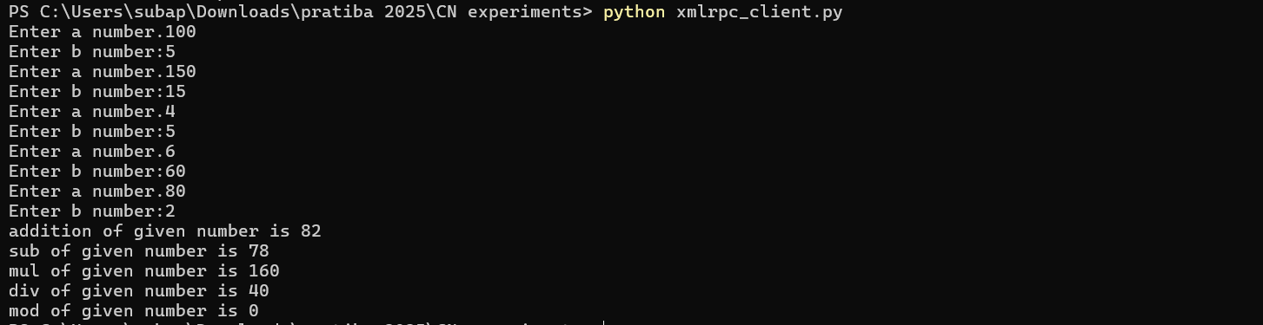

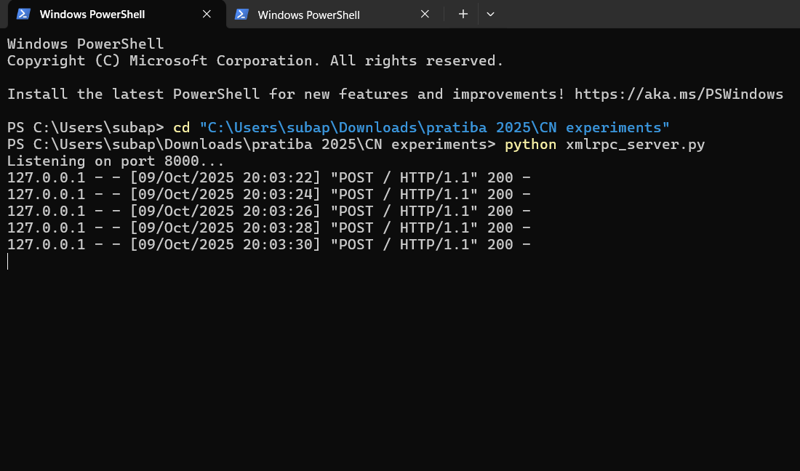

**RESULT:**

The program was successfully executed using XML-RPC in Python.  
It performs basic arithmetic operations through client–server communication.